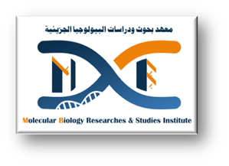



**Hasnaa Abdelwahab Mohamed**

**Demonstrator (** Faculty of medicine, Assiut University, Egypt).

**Major Field:- molecular biology**

**Minor Field:- molecular microbiology**

**Personal information**

**Place and date of Birth**

Mankabad, Assiut, Friday 27th June 1997

**Address**

Molecular biology and research institute Assiut, Egypt.

**Email**

[Hasnaa.alhussein1@gmail.com](mailto:Hasnaa.alhussein1@gmail.com)

Hasnaa_26.aun.edu.eg

**Telephone**

+0020882399475 (Home) +01112671186(Mob.)

**Nationality**

Egyptian

**Content**

**Academic education**

**2015-2023 student at faculty of medicine , Assuit University**

**Academic positions**

2023 till now demonstrator of molecular microbiology at molecular biology research and studies institute Assuit University

**Language skills:**

Arabic native language

English good

Germany limited

French limited knowledge

Japanese limited knowledge

**Computer Skills:**

ICDL/ECDL Certified

.

**4. Workshops, Scientific Visits and Additional Skills**

**Workshops:**

**1- cell and tissue culture workshop** 23-25 Oct 2023 (3 days).

1. **mesenchymal stem cells isolation and characterization** 5-6 December 2023(3 days).
2. **DNA Extraction and PCR applications** 17-18 April 2024
3. **Basics of flow cytometry** 12 december 2024(1day)
4. **Basics of scientific research** 26 Feb 2024 (7weeks)
5. **SDS Page Basics** 2-3 April 2024(3days)

**5. Research Expoereince, Conferences/Presentations and awards**

**Research Expoereince**

<((((º> ><((((º> ><((((º> ><((((º> ><((((º> ><((((º> ><((((º> ><((((º> ><((((º> ><((((º>><((((º>><((((º> ><((((º> ><((((º>><((((º>